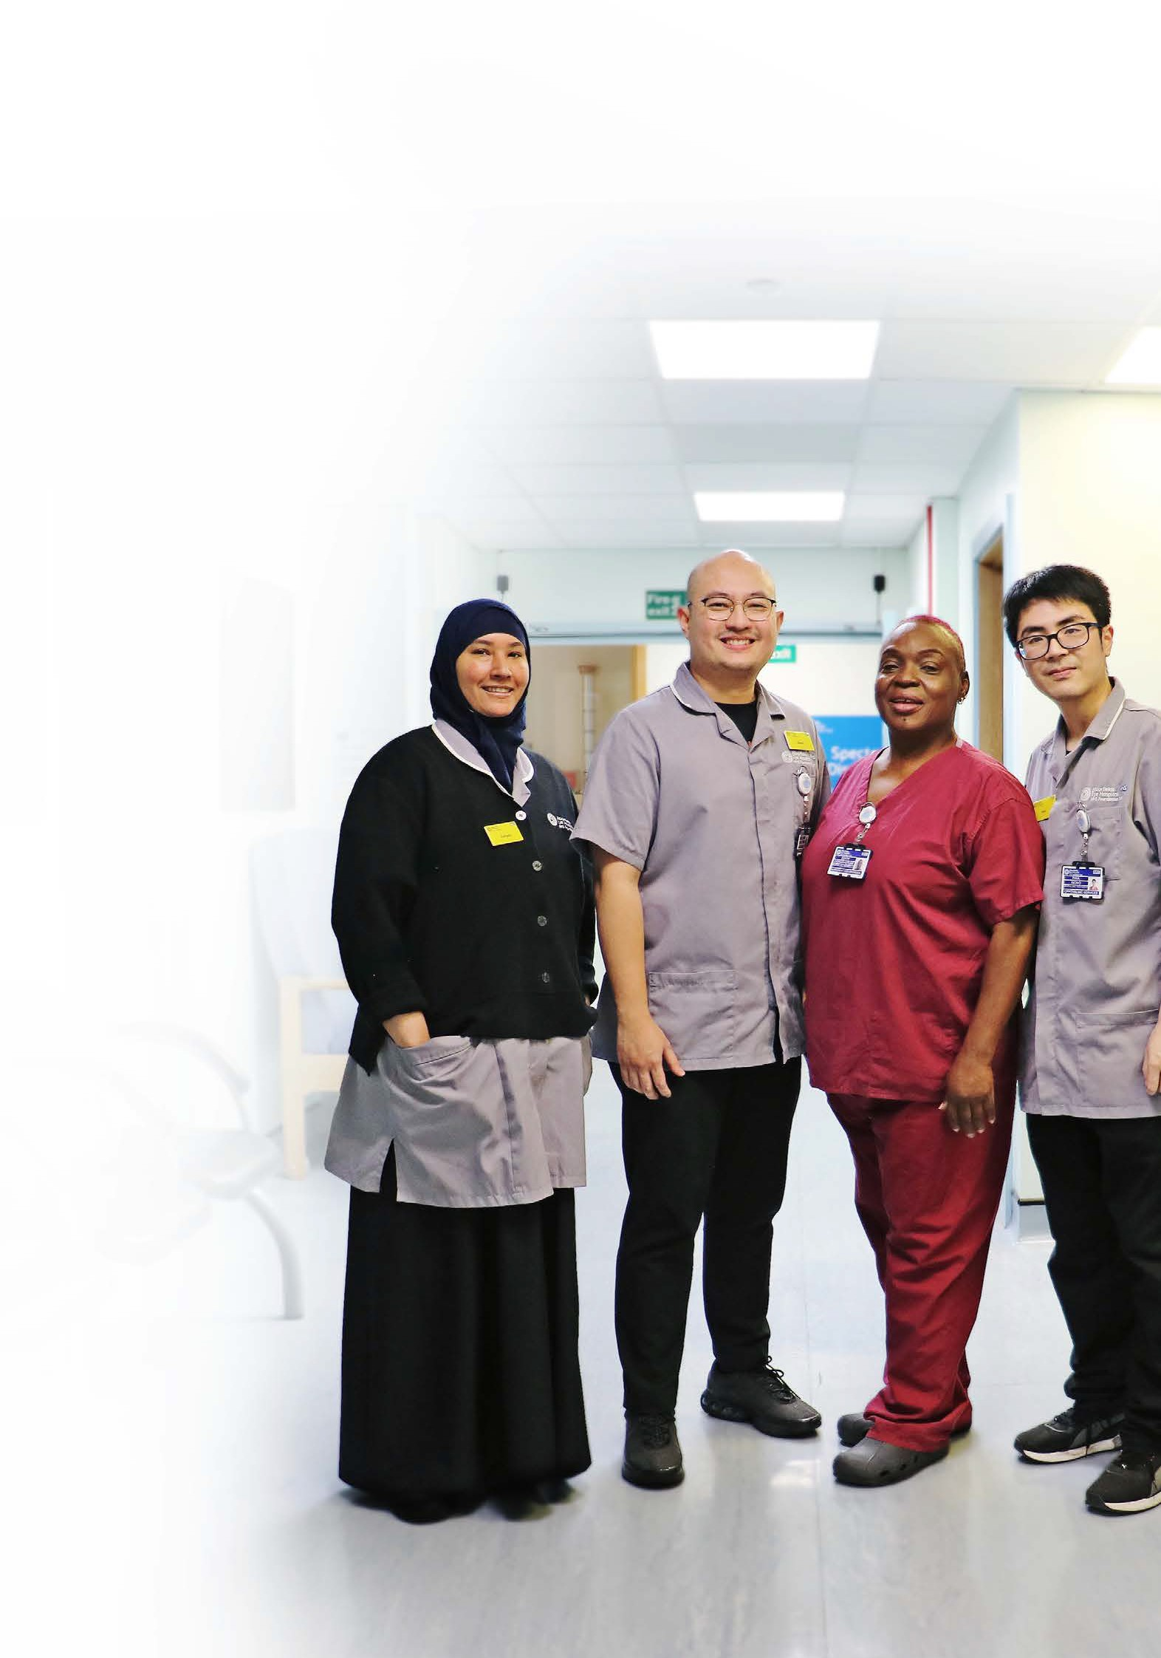
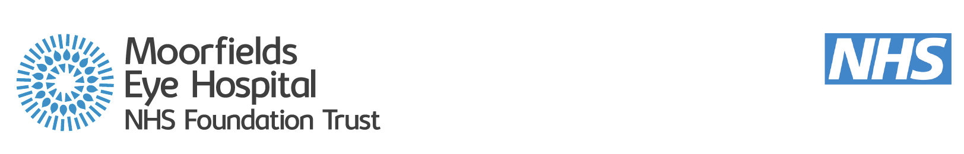
Moorfields Magazine
A magazine for patients, staff, members, carers and visitors

Acting on our values: Equity

Improvements in accessibility

New glaucoma research

Cataract excellence

Winter 2024 moorfields.nhs.uk
1



C O N T E N T S

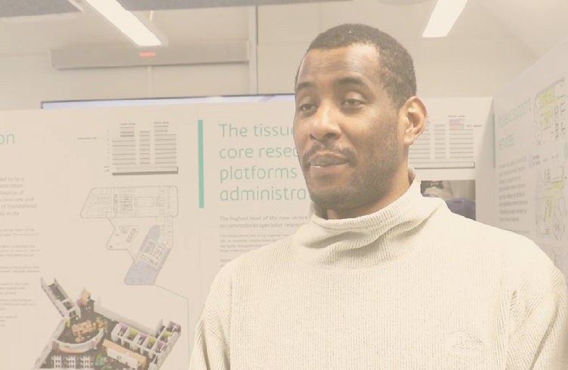

How patients
20
steered Stratford’s development

Moorfields Magazine
Please email moorfields.foundation@ nhs.net to register for regular updates from Moorfields
3 Welcome from Jon Spencer, acting chief executive
4 News in brief
10 Moorfields updates
12 Spotlight on… Moorfields at Barking

15 Operation Ouch! and cataracts
18 Research at Moorfields
20 Moorfields at Stratford
22 Accessible patient information
23 Patient experience principles
24 Smoking and your eyes
25 Our patient record
26 Moorfields Eye Charity
28 Friends of Moorfields
30 Moorfields governors and members

32 Contact details

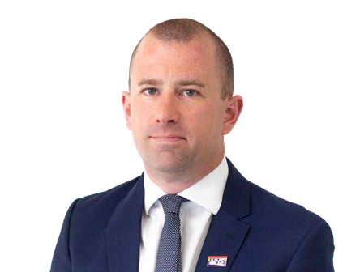
Welcome from
Jon Spencer, acting chief executive

Welcome to the winter 2024 edition of Moorfields Magazine, our official magazine for patients, staff, members, carers, and visitors.
This edition is packed with news and features, including the exceptional work by our electrophysiology department
to earn a major accreditation and the fascinating research being carried out at the hospital, identifying biomarkers that can reveal how patients with glaucoma respond to treatment.
We are almost halfway through our five-year plan, which puts our trust
values of excellence, equity and kindness at the forefront of how we offer eye care.
Over the coming magazines, we hope to demonstrate how our values are driving patients’ experience of high quality care, and the development and progression of our staff. That is why, over the next three magazines, we will look to spotlight each of our values, starting with equity and show how we are turning our values into action.
We have recently launched a new vision for equity, diversity and inclusion at the trust, Equity in action, in which we state:
“We are committed to equity, diversity, and inclusion – and open about the challenges we face. We will listen, reflect, take accountability and work together to ensure our culture is open, honest and fair for all.
“Inclusive behaviours will be championed and role embedded so everyone can fulfil their potential. Diversity will be valued and embraced in all forms. At Moorfields, we will all feel safe to share our experiences, stand up for what is right and know that we will be treated with kindness.”
We have also signed UNISON’s Anti- Racism Charter, which you can read about in this magazine.
In every Moorfields Magazine we spotlight a different department, team or site from the 20 sites that are all part of our trust. In this edition, we feature one of our smaller sites, Moorfields Community Eye Clinic at Barking Hospital, and meet its close-knit team dedicated to patient care.
I hope you enjoy reading this magazine, and I hope you find it as interesting
and inspiring as I do to learn about the incredible work being carried out by our staff to deliver excellent eye care for our patients.

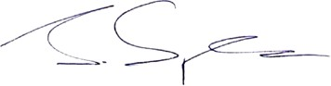
Jon Spencer, chief operating officer and acting chief executive

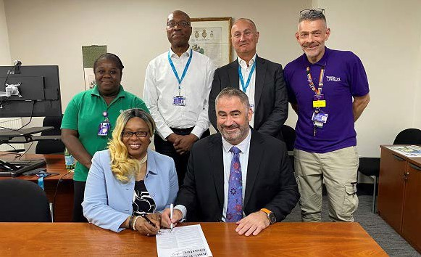
Equity is one of our core values.
By enacting the anti-racism
charter, we will help translate our values into action at Moorfields.
Martin Kuper

Equity in action
As part of our commitment to equity, diversity and inclusion at Moorfields, Martin Kuper, chief executive, signed UNISON’s Anti-Racism Charter.

The charter aims to tackle racism in the public sector and commits organisations and
their leaders to have a clear and visible race equality policy, as well as a programme of anti-
racism initiatives, such as training for all staff.
Upon signing the charter,
Martin said: “This is an important day for
Moorfields, our staff and our patients. It highlights our commitment to proactively challenging racial discrimination
and to ensure we are an
explicitly anti-racist trust.
“Equity is one of our core values. By enacting the anti-racism charter, we will help translate our values into action at Moorfields.”
Carol Shorter, UNISON regional organiser, commented: “UNISON is thrilled to see Moorfields making this commitment to being an anti-racist employer. We look forward to working
in partnership with Moorfields to implement the charter, and to make the trust a fairer and
more inclusive workplace for all.”
The trust has pledged to introduce a series of ongoing commitments
over the next 12 months, including: challenging racism internally and externally wherever it arises in relation to the trust; provide anti-racism training; providing a reporting process and wellbeing support for staff who experience racism, and processes to address race disparities in staff retention, pay and equality of opportunities.

Electrophysiology department earns major accreditation

The electrophysiology department at Moorfields measures the electrical signals between the eyes and brain to diagnose and
monitor visual problems, disease and the effects of treatment.
They have become the first vision science service in the UK to receive the Improving Quality in Physiological Services (IQIPS) accreditation.
IQIPS is a professionally- led accreditation scheme, aiming to improve
the services, care and safety of patients undergoing physiology tests, to drive better patient outcomes. This prestigious accreditation is recognised as a national badge of quality.
The department underwent comprehensive inspection and assessment in
five areas: clinical practice, leadership and management, safety and risk management, patient experience, and facilities and resource. The independent report noted the devotion to

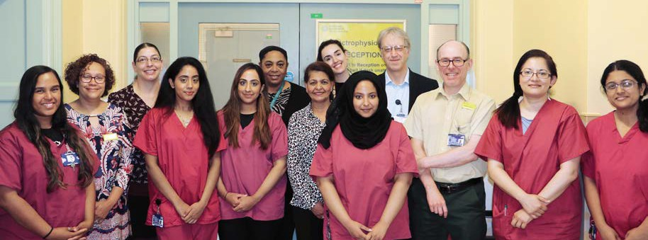
service development, and expressed how impressed they were with the quality of leadership.
Speaking about the accreditation, Anthony Robson, consultant clinical scientist and head of the department, said:
“Accreditation is a major achievement and, although awarded this year, reflects a
sustained effort and is the culmination of hard work by a dedicated team over months and years.
“It required a high level of engagement and
teamwork by all our staff, with preparations being led superbly by Magella Neveu, operations manager, supported by Anne Georgiou, education lead, and Andrew Carter, technical/systems manager, as well as the rest of the team.

“We have an exceptionally hard-working, dedicated team who pull together for the benefit of
patients, and I am immensely proud of their achievements.”
Kerry Tinkler, director of clinical support services, added:
“Achieving IQIPS accreditation for our electrophysiology department is another milestone in our journey to provide the highest of standards for our patients across all of our clinical support services.
“Being the first vision science service in the UK to achieve this is testimony to the hard work and dedication of the team and our
quality manager. I am so proud of what they have achieved, truly a world leading service.”

New Moorfields home reaches construction milestone


Photo credit: Dominick Tyler

The new home for Moorfields Eye Hospital NHS Foundation Trust and the UCL Institute of Ophthalmology has reached a significant construction milestone.
with technology playing a pivotal role in how people use the building. Patients will be able to access their care virtually via the

The completion of the
concrete structure of the new centre for advancing eye health, in St Pancras, Camden, project name Oriel, was marked with
a traditional topping out ceremony.
It is a partnership between Moorfields Eye Hospital, the UCL Institute of Ophthalmology and Moorfields Eye Charity.

Due to open in 2027, the centre will bring clinicians from the hospital’s City Road site and scientists

Photo credit: Simon Harvey
under one roof for the
first time.
Dedicated education space located throughout the building will
offer collaborative environments for knowledge sharing and learning. The centre has been co-designed by staff and patients to ensure
it offers an inclusive environment where research will flourish, staff will thrive and patients will experience seamless care. Improving access and reducing health
inequalities are an important focus.
The state- of-the-art centre will be the first NHS SMART
hospital,
centre’s ‘digital front door’, closer to home and without unnecessary visits.
Laura Wade-Gery, Moorfields chair, said: “The topping out is a momentous occasion in our journey to create an integrated centre for us to continue our world- leading research and ophthalmic care. We are extremely proud of the centre’s co-design ethos and believe we have created an environment that will enable us to continue to provide the highest quality patient
care while driving forward innovation. Ophthalmology clinics account for 10% of all hospital NHS outpatient visits and this figure is
expected to rise, so we have designed the new centre to meet future demand.”


Moorfields granted royal patronage by King Charles

Moorfields has been informed by
Buckingham Palace that His Majesty King Charles III will be continuing
a royal tradition by becoming its new patron after the passing of Her Late Majesty Queen Elizabeth II.
Moorfields was named the Royal London Ophthalmic Hospital in 1837, after its then
patron, Queen Victoria. Its current site at
City Road had its first foundation stone placed in 1897 by Edward, Prince of Wales, later King Edward VII.
Following Queen Elizabeth’s death in September 2022 and King Charles’ coronation, a review of over 1,000 royal patronages has been underway.
“I’m delighted to share that we have received news from Buckingham Palace to confirm His
Majesty King Charles III will now be patron of Moorfields Eye Hospital,” said Martin Kuper, chief executive.
“This prestigious patronage will support us to highlight the excellent work of our staff to ensure our patients receive the best care possible.
“King Charles is known for his passion for sustainability and our purpose of ‘working together to discover, develop and deliver excellent eye care, sustainably and at scale’ aligns well with this ethos.”
Her Late Majesty visited Moorfields Eye Hospital on several occasions; in 1955 to mark the hospital’s 150th anniversary,
in 1988 with the late Duke of Edinburgh for the hospital’s official inauguration after refurbishment, in 1999 to
celebrate the anniversary of the hospital’s move at City Road and to unveil the now-iconic “eye clock”, and again in 2007, to open the hospital’s brand-new Richard Desmond Children’s Eye Centre.

This prestigious patronage will support us to highlight the excellent work of our staff to ensure our patients receive the best care possible.
Martin Kuper


Moorfields celebrates its Stars

We are proud to recognise the achievements of
our staff at the annual Stars awards for 2024. This annual celebration

And the winners are…


Individuals

spotlights colleagues who have exemplified our values, including those excelling in their field.
The winners of the individual and team patient choice awards, nominated by patients, are pictured below.
Full details are on our
Adam Mapani Anthony Khawaja Ayman Gawish Brenda Marsh Bea Nagy

Teams
Cataract team Electrophysiology team
Flossie Donovan Kirsty Austin Lydia Gillan
Lea Cabaluna Naheed Phul

website.
Single Point of Access team

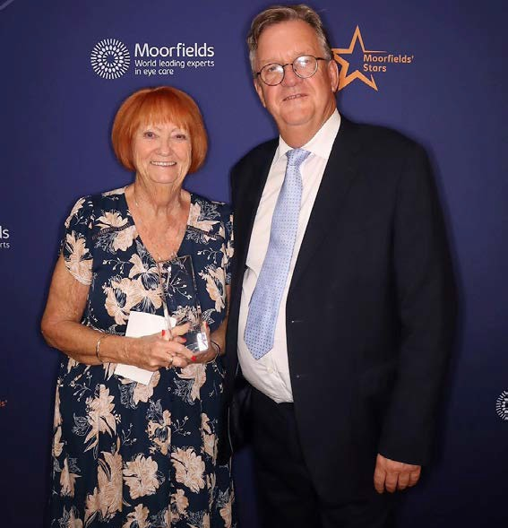
Brenda Marsh Pharmacy team

Moorfields ophthalmologists named on Power List 2024

Congratulations to the 11 Moorfields Eye
Hospital staff named on The Ophthalmologist Power List 2024,
and to all those who have supported their achievements.
Every year, The Ophthalmologist magazine celebrates inspirational clinicians, scientists and leaders in ophthalmology by
recognising the 100 most influential people through their power list.
Keith Barton, consultant ophthalmologist at Moorfields and professor of ophthalmology
at UCL Institute of Ophthalmology (IoO) was named in the top ten.
Gus Gazzard, director of surgery at Moorfields and professor of
ophthalmology (glaucoma studies) at UCL IoO was named in the top twenty.
Siegfried Wagner, specialist registrar was also recently named as a Power List Rising Star.

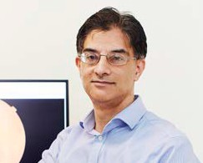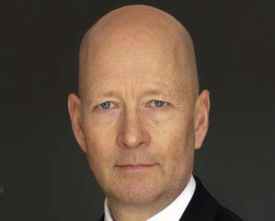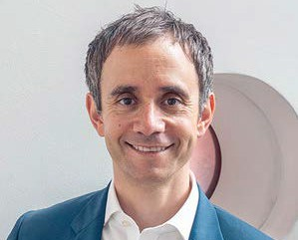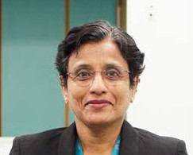

The other Power List members were (from left to right): Paul Foster, Lyndon Da Cruz, Louisa Wickham, Sobha Sivaprasad, Mariya Moosajee, Anthony Khawaja, Keith Barton, Pearse Keane, Adnan Tufail and James Bainbridge.


Accolades and achievements

Congratulations to Dr Roxanne Crosby-
Nwaobi, lead nurse for research, who has been awarded a Fellowship by the Royal College of Nursing (RCN).
The RCN Fellowship recognises innovative individuals who have made an exceptional commitment to advancing the science and practice of nursing and the improvement of health and patient care. It is the highest honour given to an RCN member.
RCN President Sheilabye Sobrany, in presenting the prestigious wards, said: “Congratulations

Congratulations to Mr Mahi Muqit, consultant ophthalmologist, who has been awarded
a Bengal British Icons award at the
House of Lords for his exceptional contributions to healthcare and biomedical research.
to all the award winners tonight. You truly represent the best of nursing.”
Speaking about receiving this honour, Roxanne said: “I am deeply humbled and honoured to receive this award
for my contribution to ophthalmic nursing, population eye health and research. For more than 80% of people, sight is considered their most important sense. Ophthalmic nurses provide holistic nursing care to aid
in the prevention, treatment and long- term management of eye conditions; an essential

These awards provide a platform to celebrate Asian success across diverse fields.
Mr Muqit was part of a team to deliver the first diabetic retinopathy screening programme in Bangladesh. More recently, he has been awarded £1.2m to


Dr Roxanne Crosby-Nwaobi
service within the most trusted profession.”
The RCN Fellowship is one of 11 awards Roxanne has received for her work in the past 12 months, including RCN Researcher of the Year, Nursing Times Digital Technology award, and Moorfields chair award for outstanding contribution to the trust.

explore a new treatment for retinal detachment surgery.
Mahi has been praised for leaving ‘an indelible mark in the field of healthcare and biomedical research’ and for ‘serving as a beacon of inspiration for countless individuals’.

10
10


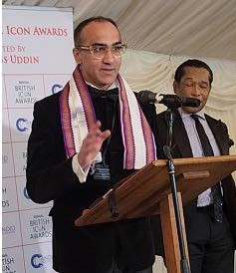
Two of our clinician researchers have been successful in their application to the National Institute of Health and Care
M O O R F I E L D S U P D A T E S
“I’ve spent over 15 years
working with Helen Keller International in setting up and scaling Bangladesh diabetic eye screening programmes,”
explains Mahi. “I am
honoured to receive this award in recognition of my charitable work in the field of international blindness prevention.”
I am honoured to receive this
award in recognition of my charitable work in the field of international blindness prevention.
Mr Mahi Muqit
Research (NIHR) Senior Clinical and Practitioner Research Award (SCPRA).
Dr Annegret Dahlmann- Noor has been funded to develop a programme of research to tackle myopia (short-sightedness) in children.
Annegret said: “I am delighted to receive the award, which will allow us to work on a topic that is very important for many children and parents, and to develop new talent within the [Moorfields
Research Centre at the same time.”
The other awardee is Dr Vijay Tailor-Hamblin, who will be using the funding to identify a set of research topics in concomitant strabismus – where one eye is mispositioned relative to the other eye that will inform future research questions for
improving care and knowledge.
Vijay will undertake patient and public engagement and involvement to identify themes. These will then be discussed in focus groups with clinicians to develop specific research questions to address these themes.

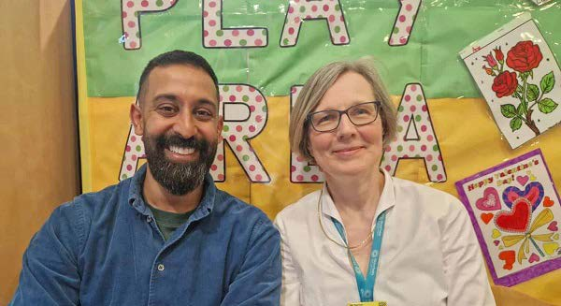
NIHR] Biomedical Dr Vijay Tailor-Hamblin and Dr Annegret Dahlmann-Noor

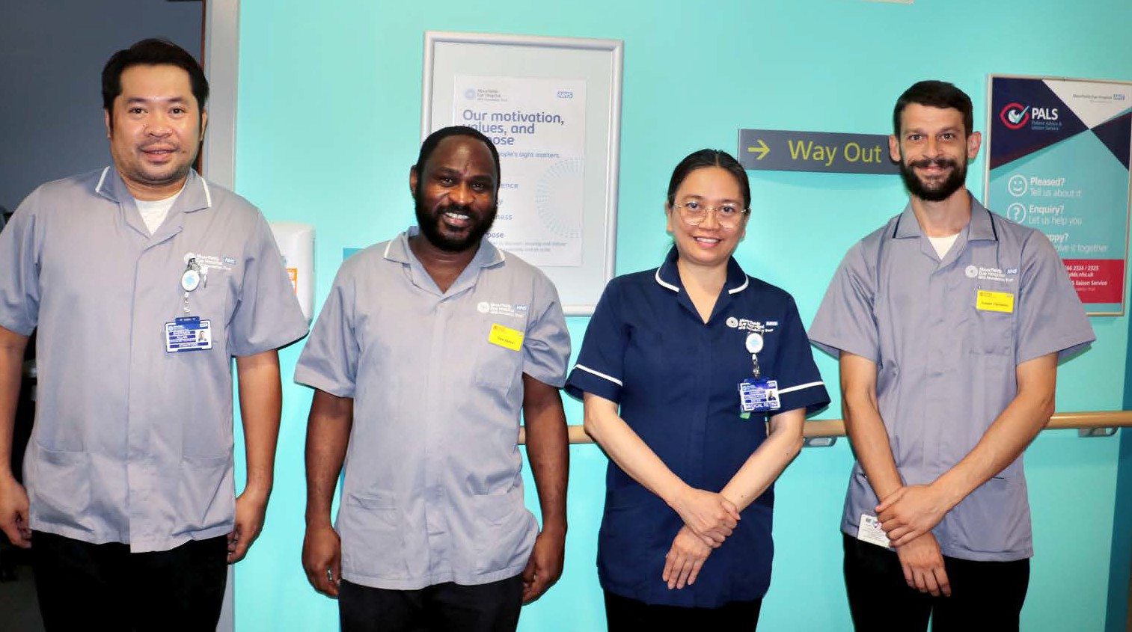
Spotlight on
Moorfields at Barking

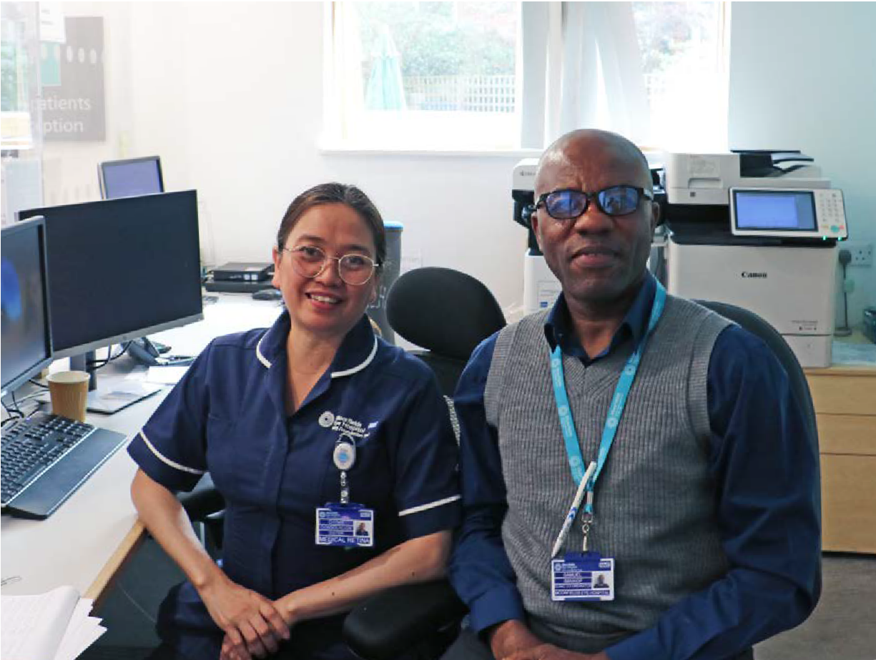
Moorfields Community Eye Clinic at Barking Hospital is one of our smallest sites, offering diagnostic tests for local people
with glaucoma two days a week.
With great accessibility and free parking on-site, patients come from as far away as Southend, Chelmsford and Dartford, as well as from Romford, Hornchurch and east London.
This service is led by the local team, with support from clinical colleagues in Stratford.

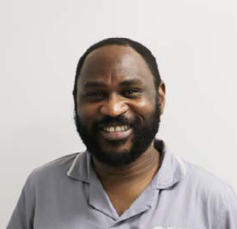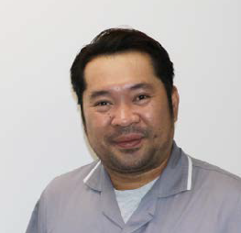

Tobechukwu Ajaere
Ophthalmic technician

Sherwen Mayordo
Ophthalmic technician

I came to the UK in 2021 and, before becoming a permanent member of staff last year, I worked at City Road, St George’s (in the theatres) and Ealing, with a private sector provider.
“Before moving to the UK, I was a doctor, having qualified in Ukraine in 2012. I worked with Médecins Sans Frontières in France, Kenya and
Cameroon as a GP and in emergency medicine. Being an ophthalmic technician gives me a chance to grow in my experience of the NHS while my licence to practice is coming through.
“I split my time between Stratford and Barking, and I always try to give my patients a great experience. I believe everyone that each patient comes into contact with contributes to their recovery, including the security team and receptionists as well as clinicians. As Barking is technician-led, we get the chance to answer more patient questions, as well as liaising with doctors when needed.
My Dad was an optician so, growing up in the Philippines, I was helping out and using machines from a young age.
“I have worked at Western Eye for two years, and Royal Free Hospital, so I am able to bring this experience into my role at Moorfields.
“Barking is special, and our smaller team here helps us work more closely together and support each other.
“Patients really appreciate it, always attending their appointments, and often coming early. Most are coming for follow-ups, so they know our names and we in turn get to know them.

“Barking is special, and our smaller team here helps us work more closely together and support each other.”

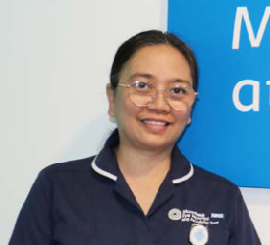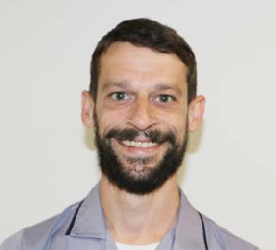

Chymie Consolacion
Sister

Joe Clements
Ophthalmic technician

I started on nights at City Road in 2000. Back in those days, even cataract patients stayed overnight. I have also served in A&E and Moorfields Private. I
moved back to the NHS side in 2008, and worked in medical retina until 2023.
“I have seen a lot of change in my time at Moorfields. Care is more systematic, and we have nurses specialising in safeguarding and infection prevention and control. Many services are now nurse-led, and Barking is technician- led, with support from me, Noreen Ging (matron), Jonathan Clarke and Michelle Chan (consultant ophthalmologists).
“Moorfields has looked after me, from my first ophthalmic nursing course right through to the current opportunities for progression and academic development in nursing, and for our technicians too.
“I am happy to work here, and the patients always seem to give us positive feedback, they’re grateful we can offer them a local service.
I have worked at Moorfields for eight years, starting as a health care
assistant, covering observations for pre- assessments, general ophthalmology and now the diagnostic service at Barking.
“Before this, I had a number of roles in an optician’s, and I have benefitted from the broad range of experience the team here has. We are able to work flexibly across the equipment, with four staff sharing six instruments, to see more patients.
“We try to create a friendly, welcoming and calm environment, and I travel across London every day to work here because of our patients, having built relationships with them in my time here.

“I travel across London every day to work here because of our patients”

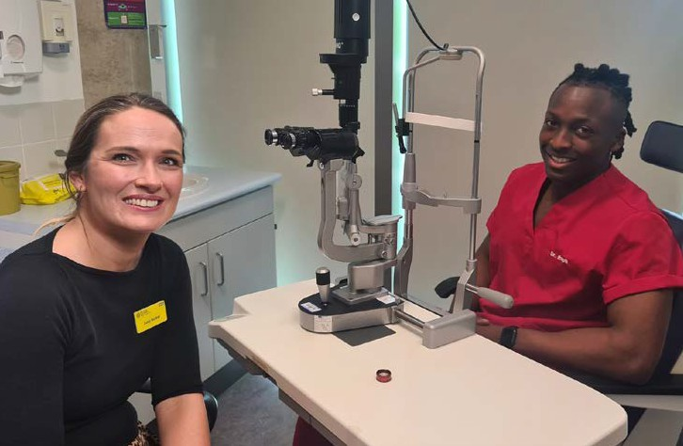
Children’s cataract services

We were delighted to host the team from hit CBBC series, Operation Ouch! into our Richard Desmond Children Eye Centre.
Presenter Dr Raphael Olaiya met with consultant
ophthalmologist Lucy Barker and several of our young patients on a visit to our paediatric clinic, to learn about what kind of eye conditions could affect them.
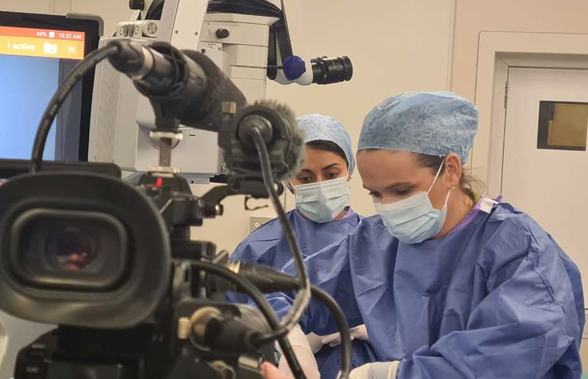
He also followed one of our teenage patients,
Nash, who had a prominent cataract in his right eye, to help raise awareness of how cataracts can also affect young people. Nash first
noticed his cataract when playing football, when he couldn’t see other players to his right.
In younger patients, it’s sometimes beneficial to not operate immediately, as their eyes are still developing, especially as younger patients also need to have cataract operations under general and not local anaesthesia.
As Nash’s cataract had grown very dense over recent months, effectively blinding him in his right eye, Lucy would go on to recommend surgery and operate.

The episode is available on BBC iPlayer.

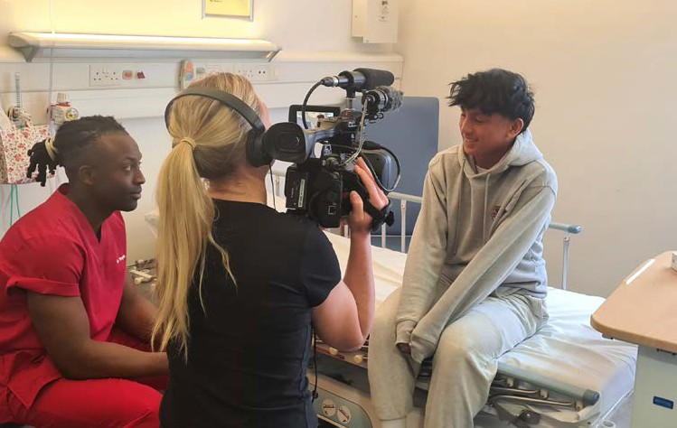

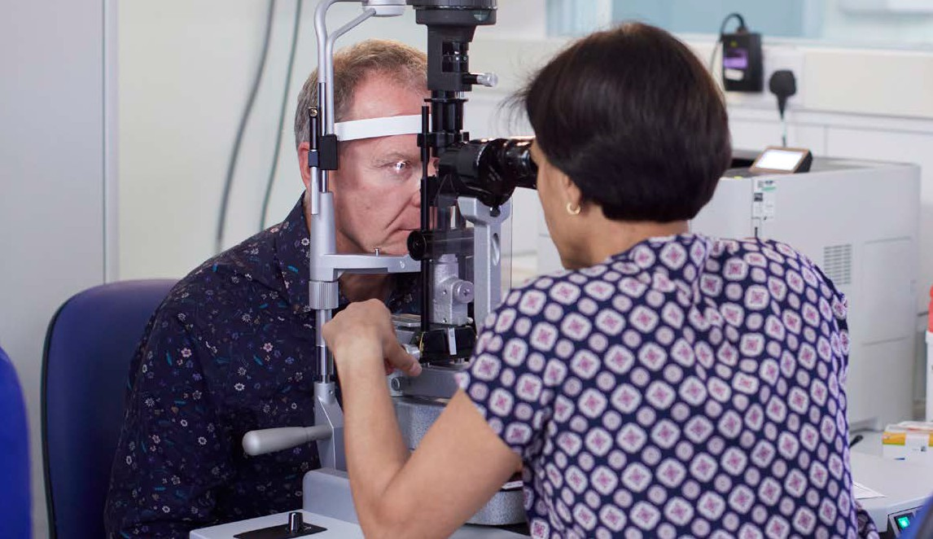
Cataract surgery at Moorfields

A cataract is when the lens – the front of the eye – clouds over, causing blurring of
vision, and often glare.
Though this is usually a gradual process, this can have a great impact on a person’s quality of life, affecting their ability to read, recognise faces, watch screens or drive, especially at night.
Cataracts can only be treated surgically, by replacing the cloudy lens with a clear, artificial lens.
Moorfields is the oldest eye hospital in the world,
performing thousands of cataract operations a year, consistently exceeding targets for surgical outcomes. It is staffed by some of the most renowned ophthalmic surgeons
in the world, who work across our network of over 20 locations.
We provide treatment for cataracts in ten different locations across London and Bedford, and can offer immediate sequential bilateral cataract surgery – operating on cataracts on both eyes, one after other - if appropriate. We offer monofocal lenses
as standard, but can also offer toric lenses to correct astigmatism.

Did you know?
Cataract operations are available at 10 of our sites, with historically short
waiting times, and any NHS patient can ask to be treated by us.
Find out more about cataracts

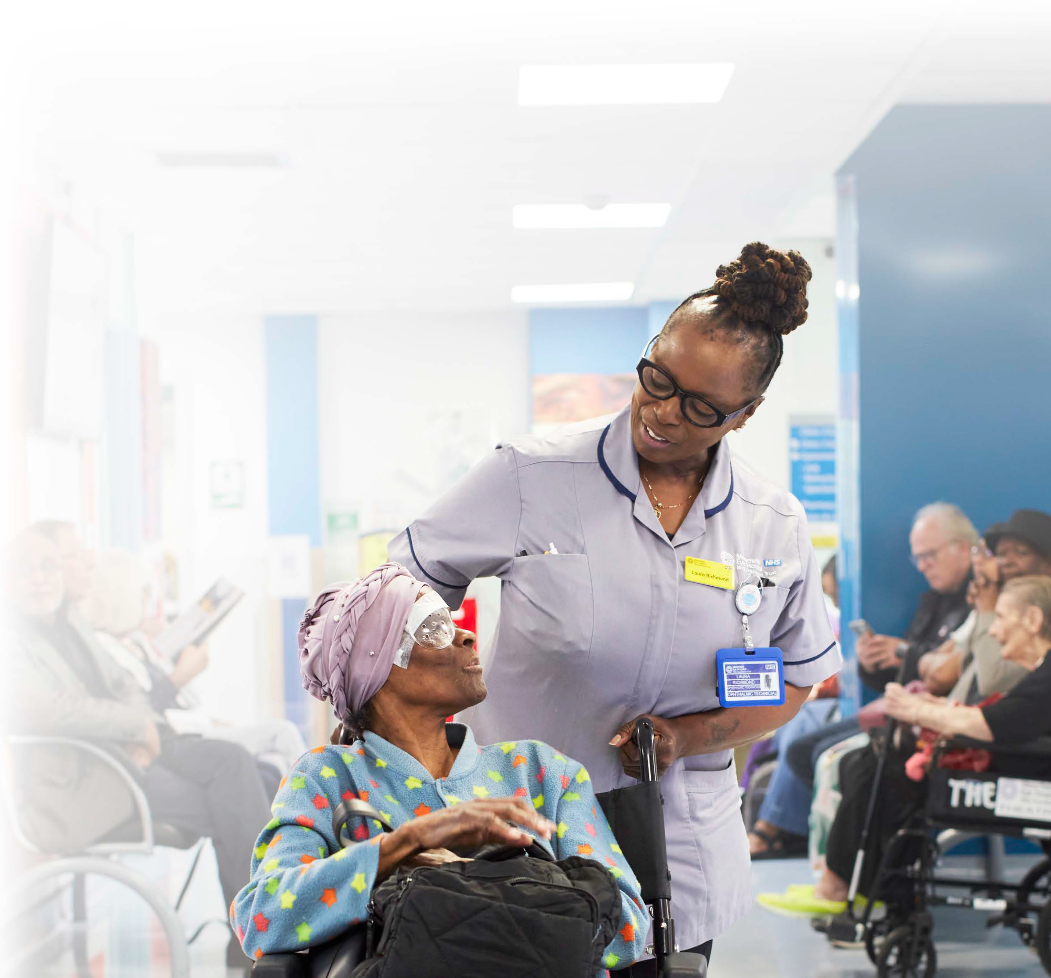

What patients say
17

“I was particularly nervous pre-op for cataracts in February and March this year,” said Marlene Perowne, patient at Moorfields Eye Hospital. “Every single member of
the team helped me to relax with their manner and took exceptionally gentle care of me prior to, throughout and after the procedure. I was even asked which music I would like to listen to during it - this was very helpful.”
“The team made me feel valued and cared for when I was feeling most vulnerable. The impact of my care was enormous. I was able to go through the procedure and feel totally at ease with the professionals caring for me when in fact I felt like running away. “

“There are no words to describe the impact of having my cataracts removed. All I can say is that they are magicians, each in their own way contributed to a successful outcome for
me and my future. They have given me a most precious gift - the ability to see the faces of my grandchildren, seeing sunrises and being able to drive safely again is totally amazing.”

Biomarkers reveal how patients with glaucoma may respond to treatment

New Moorfields and UCL research may lead to new treatments for glaucoma – the world’s leading cause of irreversible blindness.
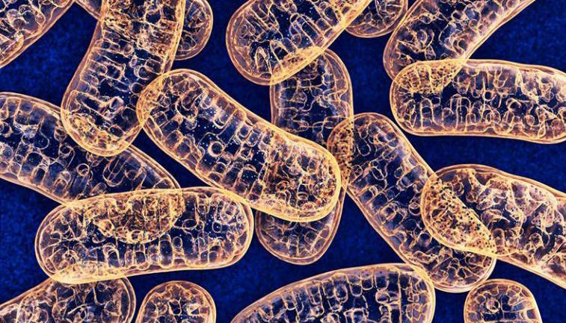
Markers in the blood that predict whether glaucoma patients are at higher risk of continued loss of vision following conventional treatment have been identified by researchers at Moorfields Eye Hospital and UCL.
in Nature Medicine, asked whether mitochondrial function is lower in people with glaucoma than those without glaucoma, and if this is associated with the rate at which glaucoma patients lose vision.
Mitochondria are the ‘batteries’ inside cells that produce energy for the cells to function.
The researchers measured how well cells in the blood use oxygen, how much vision was lost over time and the levels of nicotinamide adenine dinucleotide (NAD), which helps cells produce energy and is made from Vitamin B3 (niacin).
They discovered that peripheral blood mononuclear cells use

Over 700,000 people in the UK have glaucoma and it is the leading cause of irreversible blindness worldwide. The main risk factors for glaucoma are high eye pressure and older age.
Currently, all licenced treatments are designed to lower pressure in the eye, but some patients still continue to lose their sight.
This new study, published
Mitochondria under microscope

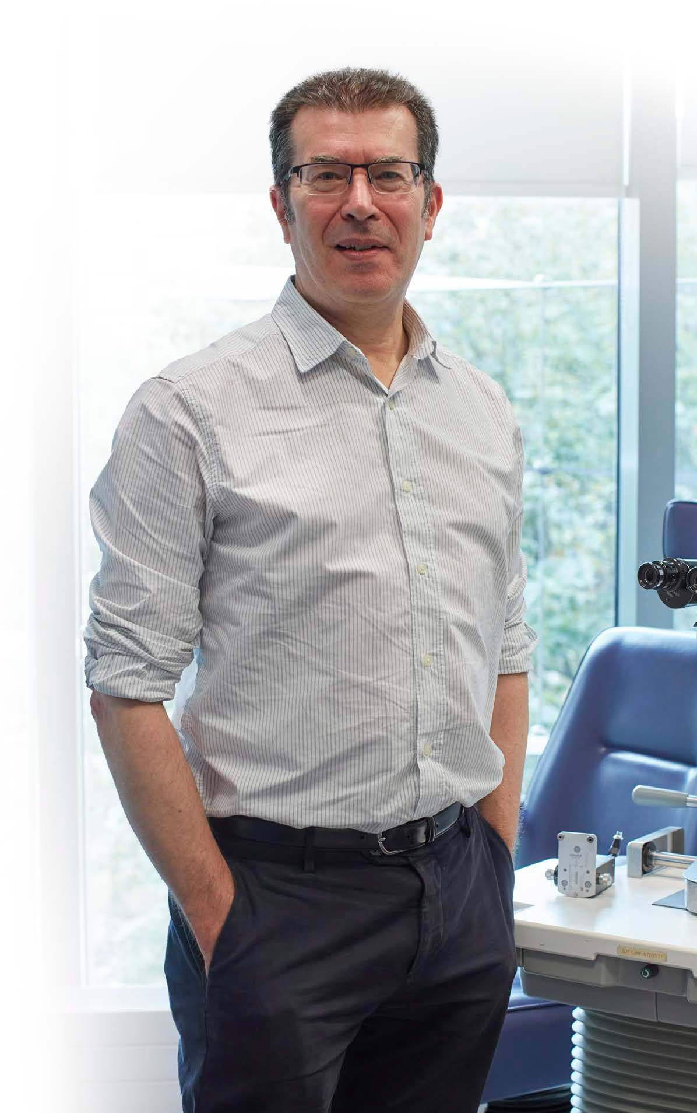


less oxygen in people with glaucoma. This explained 13% of the differences
in the speed at which patients lost vision.
Additionally, people with glaucoma were found to have lower levels of NAD in their blood cells, this being due to the lower oxygen use in the blood cells.
Senior author, Professor David (Ted) Garway- Heath said: “If introduced as a clinical test, this would enable clinicians to predict which patients are at higher risk of continued vision loss and prioritise them for more intensive monitoring and treatment.
“If further research shows that low mitochondrial function or low NAD levels are a cause for glaucoma, then this opens the way for new treatments.”
Professor Garway- Heath’s team are currently leading a major clinical trial to establish whether high-dose vitamin B3 can boost mitochondrial function and reduce vision loss in glaucoma.

Professor David (Ted) Garway-Heath
19

Click here to hear Ted explain his team’s research on BBC Radio’s In Touch programme.

How patients steered Stratford’s development

Patients were involved in several aspects of the development of Moorfields at Stratford, our newest site, which opened last year. Its central location, at a major rail, bus, tube, DLR and road hub, makes it convenient
to patients across east
London and much of Essex, but also presented potential
challenges to patients.
These included Chris Telesford, who already works with Moorfields on a voluntary basis as a patient safety
partner, helping us with patient safety, clinical governance, medical technology and patient complaints, and serves on the Oriel advisory group; but this work was different for him, as he explains:
“Supporting Stratford was personal for me.
I grew up locally, living in Canning Town as well as Stratford, and I know the area well – I even support West Ham!
“Stratford town centre is busy, so one of my main concerns was helping patients to travel to the site safely.
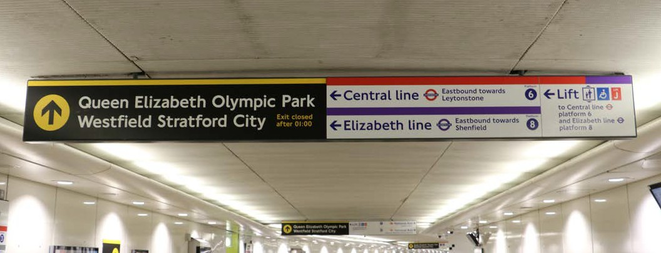
Through our engagement team, we organised a

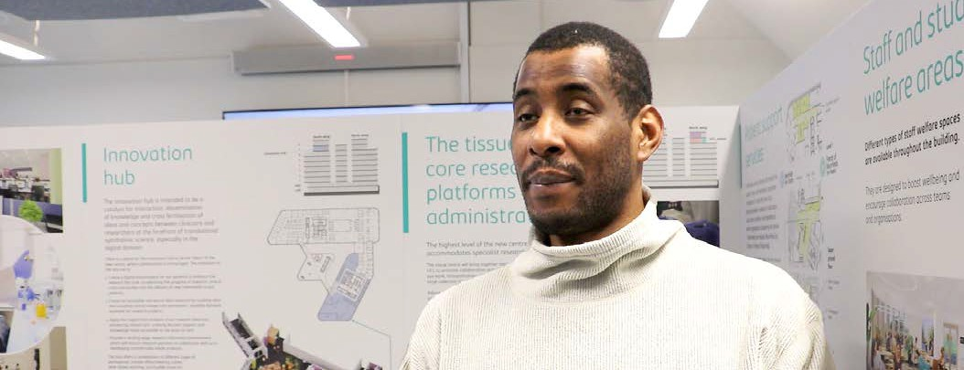
Chris Telesford
walkabout with staff and stakeholders, including TfL. We each had different eye conditions and were able to explain what we could see and what was causing us difficulties.
For example, I whizzed through the station, but couldn’t see the sign to the lift (below), because it was surrounded by so many

other signs.
“As a result of this activity, Moorfields now guides patients around the shopping centre, not through it, crossing the High Street at quieter and safer lights. I’ve been able to record videos of the walks to the station from Stratford and Stratford
High Street stations.

“We also helped with interior and exterior signage and leaflets, and the security team in the shopping centre were given leading and guiding training so they could help people choosing to take this route.”

Chris’s other passion is taekwondo. He regularly fights with (and defeats) sighted men, represents GB in Poomsae and is currently in training
for the British National Championships in October 2024. If anyone would like
to try the sport, please email him on
christopher.telesford@ nhs.net.

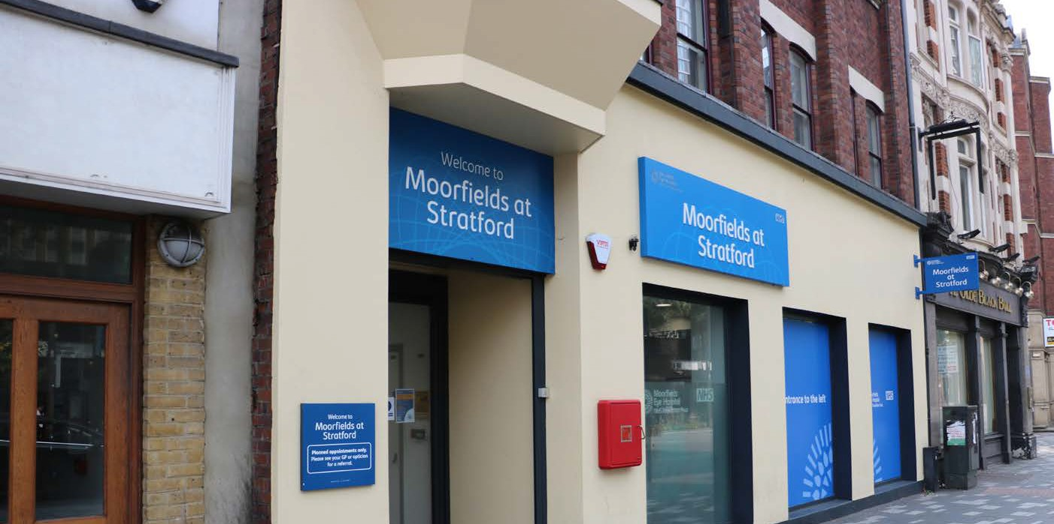

Supporting Stratford was personal for me. I grew up locally, living in Canning Town as well as Stratford, and I know the area well – I even support West Ham!

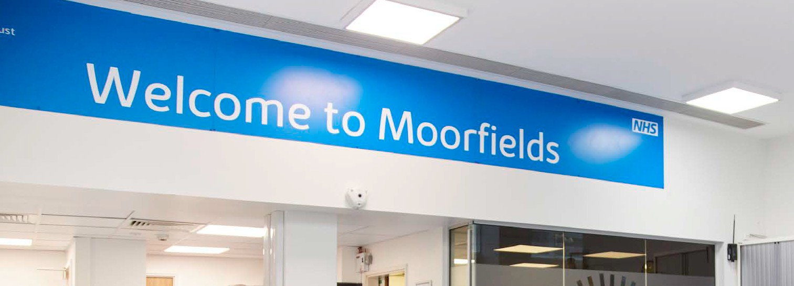
Providing accessible patient information

We strive to deliver excellent, equitable, and compassionate care
to all our patients. We also have a legal duty to provide accessible care, not just for those with sight loss, but for all patients with accessible needs.
This includes providing healthcare information in ways that our patients can access and understand.
Over the past few months, we have made
important changes to how we identify and record patients’ accessibility needs to ensure we can provide information and
support services that are individual to each patient.
We aim to provide appointment letters digitally, via our patient portal DrDoctor. Our clinic outcome letters are currently sent in the post but will be available via the patient portal soon.
As well as providing information digitally, to allow for ease of use online via assisted
technologies, we can offer the following services to our patients:
Large font letters and leaflets
Easy Read format letters and leaflets
Braille format letters and leaflets
Verbal and visual communication support, including British Sign Language interpreters
and Deafblind communicator guides
Hearing loops in clinics
If you would like to use our online patient
portal, or have a specific communication or support need, please call or email your clinic and
a member of staff will update your details.

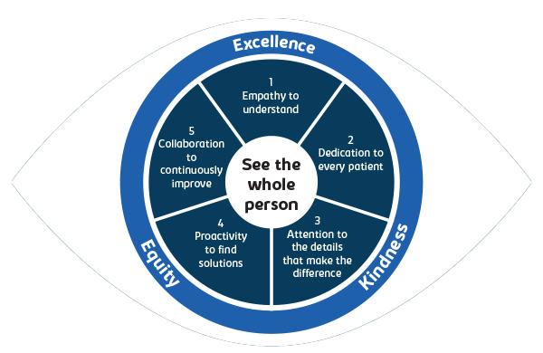
Patient experience principles

Moorfields has introduced new patient experience principles. Co- created by patients, staff and volunteers, these five principles underpin how we will consistently develop and deliver compassionate and excellent quality of care to our patients.
The five principles of ‘Empathy to understand’, ‘Dedication to every patient’, ‘Attention to
the details that make the difference’, ‘Proactivity to find solutions’,
and ‘Collaboration to continuously improve’, will help us to ‘See the whole person’ every time we
communicate with and provide care for patients across our sites.
Through an innovative trust-wide programme, staff across our sites are taking part in patient experience action labs to work together to bring about positive change in their areas of care.

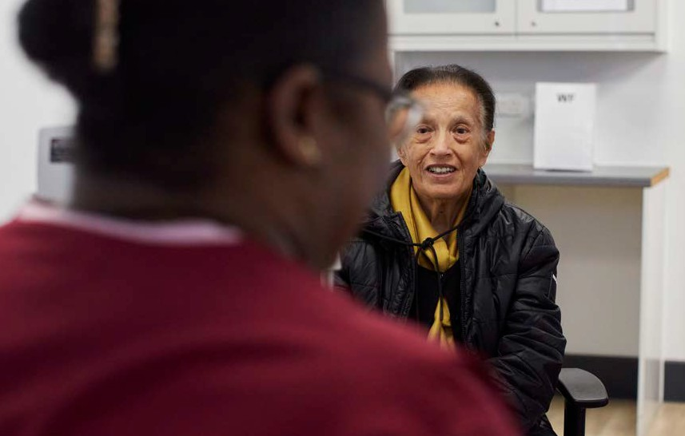
How patients can get involved
If you are a patient or carer and would like to help inform this work, please contact our patient experience team at moorfields.
contactpatientexperience@nhs.net

Smoking and your eyes

It is well documented that smoking can cause cancer and heart disease, but the effects
of smoking on eye health and sight is less known.
Research shows that smoking has been associated with increasing your risk of developing:
Age-related macular degeneration (AMD), which is the most common cause of sight loss in the UK. If you already have some form of the condition, research indicates
that smoking may also be associated with progression to more advanced forms of AMD.
Cataracts
- particularly development of nuclear sclerosis, which is the most common type of age-related cataract.
Research has also highlighted that smoking may be a potential risk factor associated with developing glaucoma.



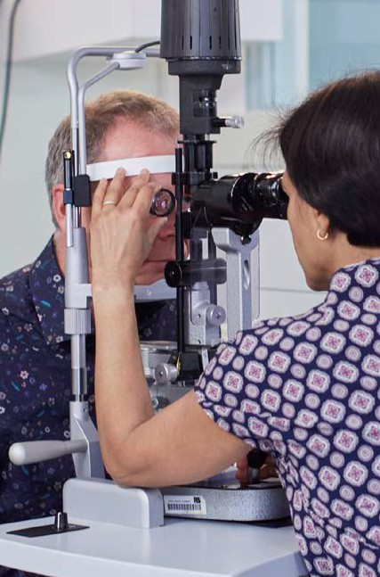
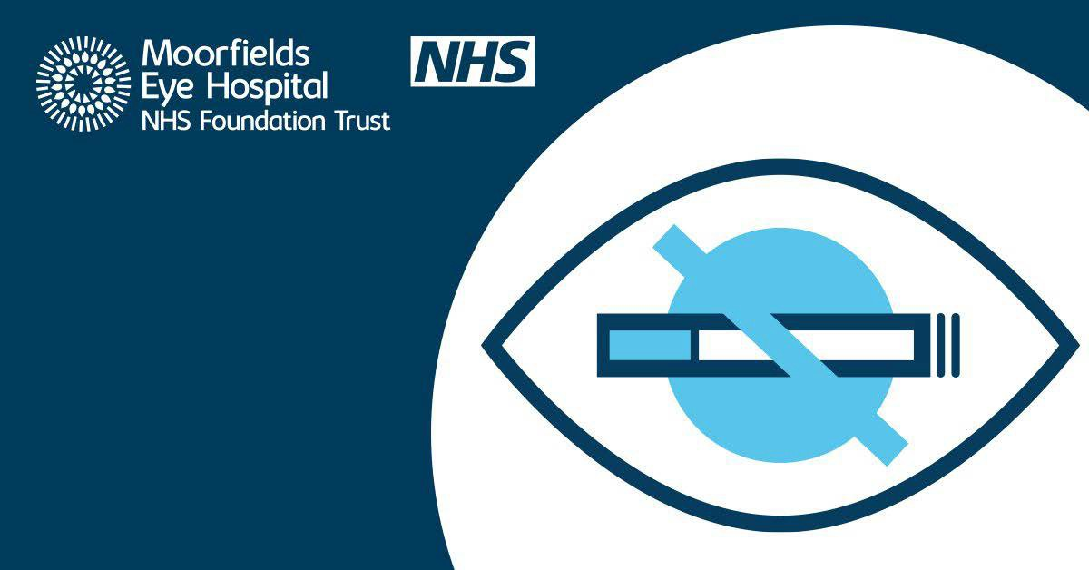
As part of our commitment to make every contact count with our patients, we are raising more awareness

For more information on how smoking effects your sight, and advice
on how to stop, visit our website at www.moorfields.
nhs.uk/for-patients/ information-hub/ smoking-and-eye- health

of the effects of smoking on eye health and encouraging patients to seek help to stop smoking.


Our patient record

The trust is currently working to deliver a new Electronic Patient Records (EPR) system. This new system is designed
to transform how we provide clinical care by enabling everyone involved in a patient’s care to have real-time
access to their up to date records.
This means:
Smoother patient journeys. Patients no longer have to give the same information multiple times or wait for data or records to be transferred. All the
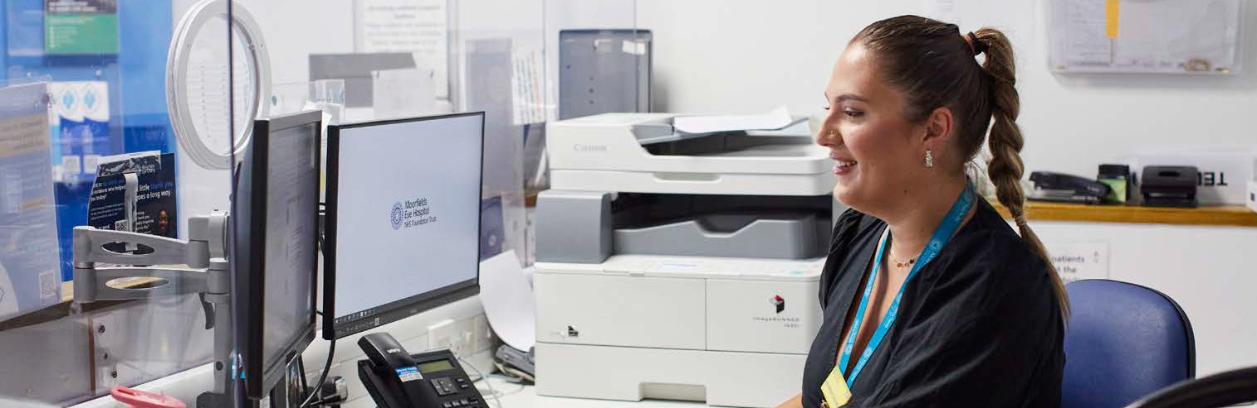
information is available to all Moorfields
clinicians, across sites and departments.
Optimised patient care. Staff will have a complete, live view of a
patient’s record to ensure they get the right care at the right time, including vital information like allergies, accessibility needs and safeguarding issues.
Seamless integration. The new EPR will integrate with our current specialist noting system, OpenEyes, to cover functionality it doesn’t have. This will allow for functions such as digitised surgical pathways and digitised A&E and pharmacy
departments.
More sustainability. As we become more digitised, we will reduce paper notes (and our carbon footprint) in our steps to becoming more sustainable at scale.
Adopting a new EPR will also be crucial for our planned move to a new centre for eye care, research and education to ensure we’re offering
modern, patient-centred and high quality care.
We are working with MEDITECH to
deliver our EPR system early in 2026.



Showing love for Moorfields staff

“Thank you for looking after me since 2014!”

“Thank you for your amazing care and wisdom during my cataract operation today. You made me feel very at ease about the procedure and I’m very grateful for everything
you do.”

Moorfields Eye Charity’s new initiative ‘My Thank You’ makes it easy for patients and supporters to say thank you to a staff member or volunteer who went above and beyond.
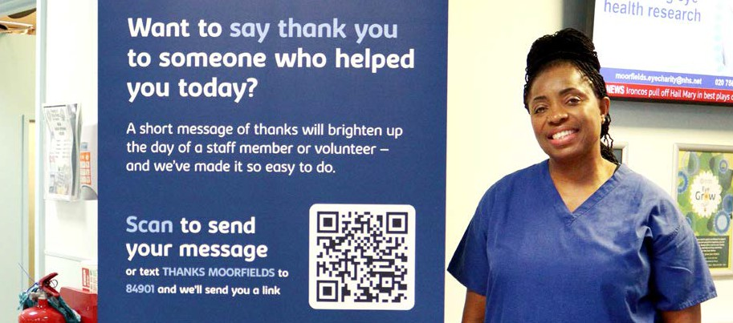
“Your care has been life changing for me. So grateful!”

To share your thanks, just scan the QR code
or text THANKS MOORFIELDS to
84901 to get started.


Eye to
“From the time I walked through the door... I was treated with care and respect. You were wonderful. NHS at its best.”
Eye – thank you to our walkers!
26

You’ve raised over £1 million since
the Eye to Eye walk launched 10 years ago.
Join us next year on Sunday 22 June 2025. Register from January 2025
moorfieldseyecharity.org.uk

Helping families understand primary congenital glaucoma (PCG)

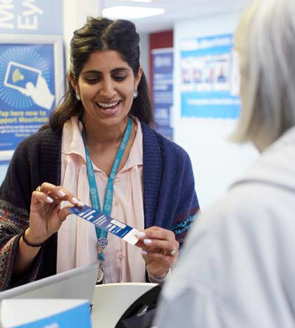

Moorfields Eye Charity awarded Dr Nicola Cronbach, ophthalmology registrar, a Research Training Fellowship to undertake a PhD to investigate PCG.

Enter the Christmas raffle today
You could win £5,000 and many more prizes, while making a
difference to the lives of people with sight loss - both today and in the future.
Whether it is used to fund the next research breakthrough for sight loss treatments,
improve the experience of Moorfields’ patients, or help educate the next generation of eye care specialists – your entry will help to save people’s sight.
Enter by 13 December.
Draw takes place on 18 December.
It’s a win win!
PCG is the most common form of glaucoma in babies and small children, typically diagnosed before the age of three.
Whilst rare, this is a serious eye condition

Nicola Cronbach
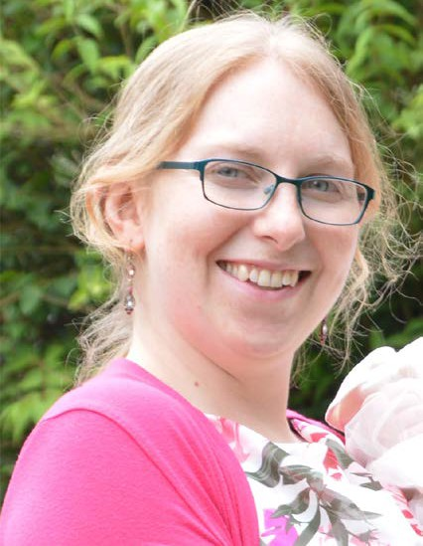
that can lead to loss of vision if left untreated, due to the increased pressure in the eye, which can damage
the fibres that make up the optic nerve.
We know that PCG is caused by changes in our genetic code,
known as mutations. “I am so grateful
to Moorfields Eye
Charity to be given this opportunity to discover more about the genetics of PCG and fulfil a long- awaited hope for those families affected by this devastating condition,” said Dr Nicola Cronbach.
Nicola will focus on uncovering novel genes that contribute to PCG and hopes her work will also lay the foundations for personalised treatments to help prevent or slow down sight loss.

£1 million donation for Oriel

Friends of Moorfields has pledged £1 million to Moorfields Eye Charity towards a new centre
for advancing eye health, opening in 2027.
The centre, in St Pancras, Camden, will be the new home for Moorfields Eye Hospital and the UCL Institute of Ophthalmology (below right) when they move from existing sites in Islington. It will be an
exemplar for patient care worldwide.
Friends’ 300-strong volunteer service, alongside their staff
team, will move to the new centre as it opens, continuing to provide practical and emotional support to patients – from directions and guidance to eye health advice
and handholding during procedures.
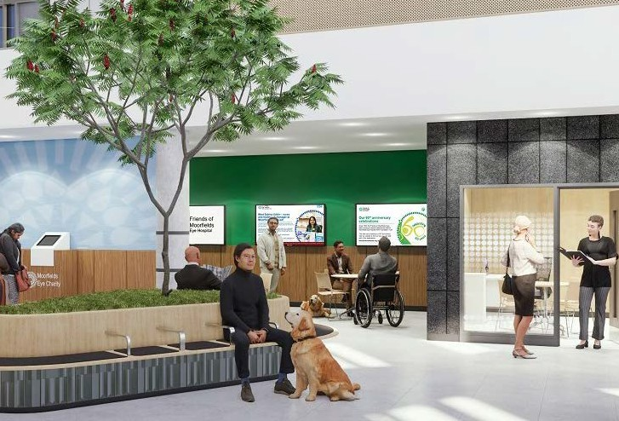
Robert Dufton, chief executive, Moorfields Eye Charity, said: “We’re so very grateful to the Friends of Moorfields Eye Hospital for their donation. This gift is helping to make the new centre possible – with patients’ needs at its heart.”



We’re so very grateful to the Friends of Moorfields Eye Hospital for their donation. This gift is helping to make the new centre possible – with patients’ needs at its heart.

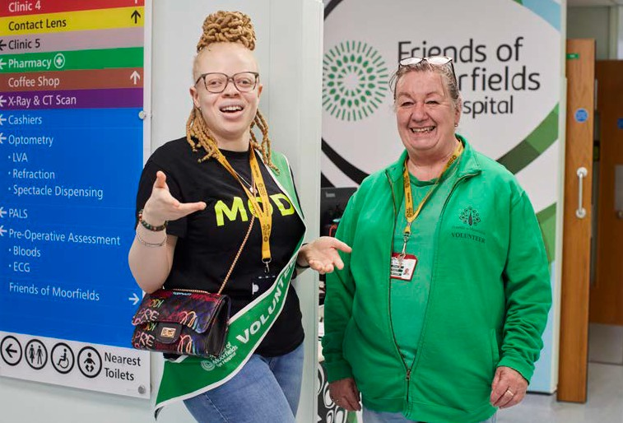

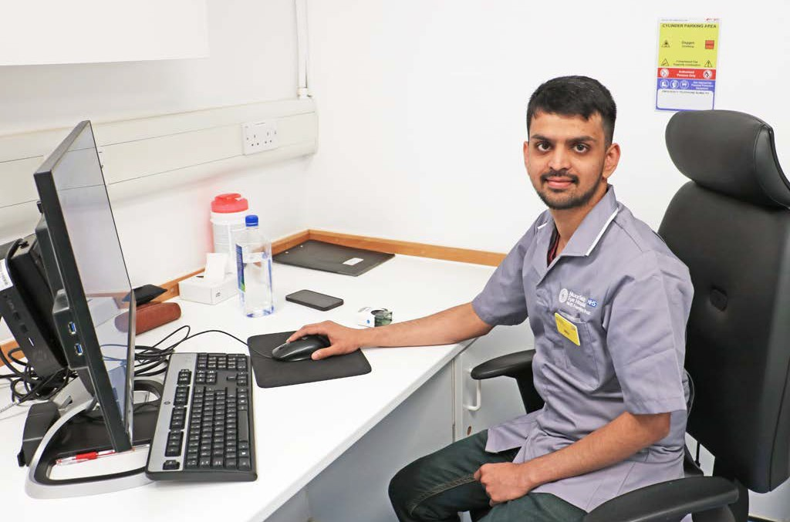
I discovered my current role as an ophthalmic technician with assistance from Friends of Moorfields.

Volunteer to Career pathway success continues

Mihir Patel (above), who started as a Friends volunteer in 2023, has benefited from Friends of Moorfields’ Volunteer to Career pathway into paid employment.
This began in 2022 as a pilot scheme and was
so successful that it has now been permanently adopted. Volunteers who are interested in careers in health and care can get support and advice about applying for permanent roles, apprenticeships and
further training.
“I discovered my current role as an ophthalmic technician with assistance from Friends of Moorfields,” says Mihir. “Their encouragement and support played a crucial role in my decision to apply.”
“The Volunteer to Career pathway continues to be very successful,” says
Natalia Tomashpolskaya, Volunteer Service Manager. “This means we can work with
Moorfields to address some of their workforce needs, but we’re also upskilling volunteers and supporting them with opportunities to step into careers within the NHS.”



Being a governor at Moorfields

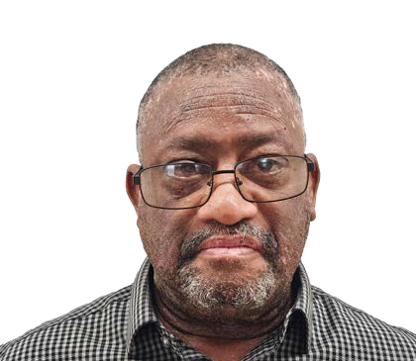
Sean Cooke

Moorfields patient Sean Cooke is a newly elected Moorfields governor for North East London.
I was born in London to Barbadian parents, a lofted cover drive from Lords cricket ground, but have lived in east London for the last 53
years. I support Essex and the best football team in London (Orient).
“In my current job, I help people achieve their potential when their background may hold them back. My first job was with people on benefits, I progressed
to being a taxman, then I swapped the suit for protective gear at Gatwick - I’m probably the only Moorfields governor to stop a woman bringing 4kg of drugs into the country. I even worked for 13 months on the London
Olympics and liaised with over 400 councils setting up Covid test centres.
“My involvement with
Moorfields started in 1987. I had surgery reattaching a retina, with a freezing operation to prevent the other detaching, then multiple appointments over the years.
“In January 2020, deterioration in my right eye meant a cornea graft and cataract surgery, and last year I had a graft in my left eye. I will need
to be reviewed for the foreseeable future.
“I stood as a governor to give something back. If it wasn’t for Moorfields, my eyesight would
be limited at best. I have around 40 years’ experience as a patient and in public service, helping those who need it and holding others to
account if required. And, in semi-retirement, I want something that I can really get my teeth into.
“It has been a varied and inspiring start - and wow, there is so much to do! Formal meetings,
election of non-executive directors, annual reports… plus volunteering too, including calling patients about appointments and reassuring corneal graft patients.
“And I am truly inspired by the rest of the governors, an awesome bunch of like-minded people wanting to make Moorfields a better place for the public and staff alike.”


How to become a governor
If you would like to express your interest in becoming a governor of Moorfields, please email moorfields. foundation@nhs.net

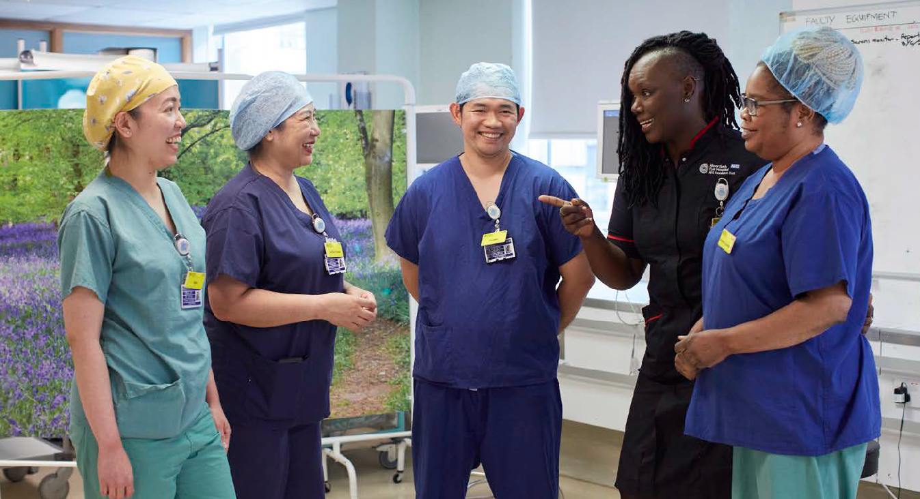




Dates for your diary 2024

Become a member
If you are keen to explore other ways to support Moorfields, you can join us as a member.
Membership is free and all members have a say in how the trust develops, giving the community and our patients the opportunity to shape
the future of the services we provide.
To become a member, contact moorfields.foundation@nhs. net

Board meetings
23 January 2025
27 March 2025

Membership council
4 March 2025

Please email moorfields. foundation@nhs.net to attend (via Microsoft Teams).

C O N T A C T U S

Moorfields Eye Hospital NHS Foundation Trust
162 City Road, London EC1V 2PD
Tel 020 7253 3411
Web moorfields.nhs.uk

Follow us on
@MoorfieldsEyeHospital @Moorfields
 @moorfieldsnhs

Moorfields Private Outpatient Centre
9-11 Bath Street, London EC1V 9LF

Moorfields Private Admissions and Refractive Suite
Fourth Floor, 162 City Road, London EC1V 2PD
Tel 020 7566 2803
Email enquiries@moorfieldsprivate.co.uk

Follow us on
@MoorfieldsPrivate @Moorfields_pvt

Moorfields Eye Charity
162 City Road, London EC1V 2PD
Tel 020 7566 2565
Email moorfields.eyecharity@nhs.net

Follow us on
@MoorfieldsEyeCharityLondon @EyeCharity
 @Moorfields_eye_charity

Friends of Moorfields
162 City Road, London EC1V 2PD
Tel 020 7251 1240
Email friends@moorfields.nhs.uk

Follow us on
@FriendsofMoorfields @MoorfieldFriend
@Friendsofmoorfields


Moorfields operates over 20 network sites across London and Bedford, bringing the same excellent eye care closer to home for our patients. To find more details on our locations, please visit: www.moorfields.nhs.uk/ locations

To receive this publication in an alternative format, or to ask to receive it regularly, please contact moorfields.foundation@nhs.net.

